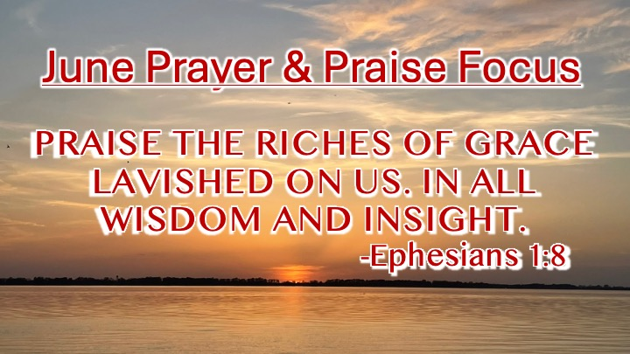
First Baptist News & Info |  |  |  | June 28, 2024
Prayer Focus for month:
Ephesians 1:8

Praise to the Lord: |  | Hoping that you’ve noticed, as we have gone through these verses from Ephesians chapter one, that Paul has been writing spiritual thoughts for spiritual people. This letter is written to Christians so that we may know and understand the fullness of God’s favor and the sufficiency of His grace. Read verses 1-14 and consider who God is, what He has done, and what we will be; then we can understand better why we should give Him all our praise.
Giving of Tithes & Offerings can be done online at anytime. Find this link on our website homepage https://www.fbcdickson.org/online_giving
or use the Realm Connect app and click this symbol at the bottom of the page.

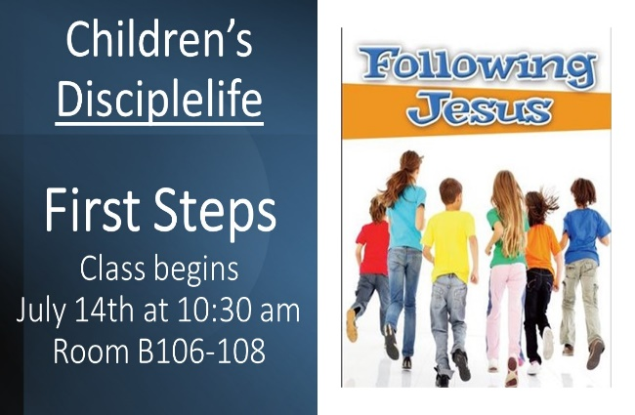  Attendance/Offerings: June 23 , 2024  - Sunday Morning Worship – 430  - Sunday School – 495  - Online Worship – 61  - Wednesday attendance – 164 (Youth at camp – 59, Children at camp – 35)  - Tithes & Offering Budget: $27,623.57 Sacred Trust: $500.00  Have you missed a sermon or a Wednesday night Bible Study? Messages are loaded weekly on First Baptist Church – Dickson, Tennessee Podcast. You can listen anywhere on your devices. https://www.fbcdickson.org/news/new-podcast  Ministry Report this Sunday, June 30th at 5 pm. Please join us to celebrate the growth and plans of our church! |  | Upcoming Activities  - Wednesday, July 3rd – 7 pm – 9 pm - Independence Day Fellowship (Music, Games, Snacks, Fireworks)  - July 6th – 13th – Guatemala Mission Trip  - Saturday, July 20th - Ladies trip to Westwood Baptist for Samaritian’s Purse Pack a Shoebox Day event. Cost per box is $10, shuttle leaves at noon – limited space. Signup on bulletin board  - Saturday, July 27th – Women’s Prayer Breakfast – begins at 8 am in the Fellowship Hall
Mid-week & Worship Opportunities this Summer
- Fellowship Hall: Pastor’s Bible Study – 6:30pm
- DiscipleLife Classes: 6:30pm, C-Hallway, Guest Central, Youth Building
- Children’s Activities: Children’s Activities: 6:30 pm childcare for birth through ages 3, Mission Friends, RA/GA classes (Pastor Ken Metcalf, Children’s Minister)
- Student Activities: 6:30 pm Conference Center (Pastor Tim Hopper, Student Minister)
- Adult Choir: 6:30 pm (Pastor Jeff Clark)

- Regular Worship at 9 AM and 10:30 AM in the Sanctuary. The 10:30 AM service will be livestreamed via Facebook and YouTube. Sunday School classes are available for all ages at 8:00 AM (adults only), 9:00 AM (all ages), and 10:30 AM (adults and Preschool only)

