Advent
A Study for Families

‘That It Might Be Fulfilled’

Advent is not just a passive waiting; it is anticipating Jesus; in mind, body, and spirit! Advent intentionally focuses on the Biblical promises, prophesies, and fulfillment that surrounds the birth of Christ. During Advent, the church, looks back upon Christ’s coming in birth with celebration while at the same time looking forward in eager anticipation to the second coming and His return for His people.

The real meaning of this Season of Advent is to spend time reflecting on the true meaning of Christmas - The Life of Jesus Christ. May we turn our focus heavenward and actively await Jesus drawing near to us this holiday.

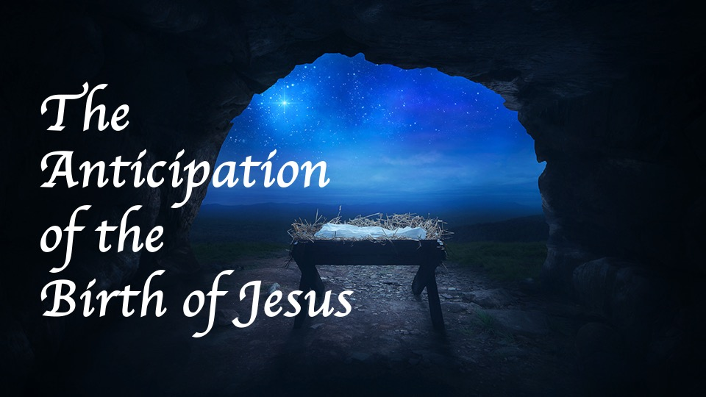
We are waiting for Christ to come once more; our Savior to return to earth just as He has promised. Heaven hears our prayers; our Father knows our heart and needs. Jesus is waiting for all of creation to respond to His invitation…that it might be fulfilled.

Advent Week 1, December 1-7

This week we focus on Hope, Christ’s coming into the world brings hope to a world in need of salvation.

Reflect on the fact that the first believers were waiting with hope and faith for the coming of Christ. Now we not only look back at this moment with remembrance of His historical birth, but we wait in anticipation of His coming again in glory.

The Lord Himself will give you a sign: The virgin will conceive, have a son, and name him Immanuel.
(Isaiah 7:14)

And hope does not disappoint, because the love of God has been poured out within our hearts through the Holy Spirit who was given to us. (Romans 5:5)

HOPE waits and endures. Hope is secure assurance in a trustworthy God.

This week read Isaiah 9:6-7; 11:1-3, 10, Jeremiah 33:14-16, Matthew 1:22-23 and Hebrews 11:1
- What is the importance of these verses in the prophecy of the Messiah?
- What do these verses promise us as believer’s today?

[The Hope Candle, also known as the “Prophecy Candle”,
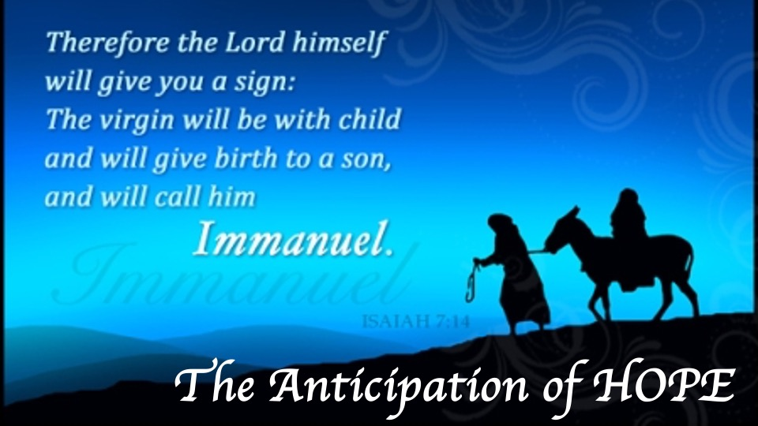
is lit this week to assure us we can have hope that God will fulfill His prophecies. Hope given to a lost world – a Messiah; hope in knowing that Jesus will return.

Advent Week 2, December 8-14

This week we focus on Peace, the Bible has a lot to say about peace, as it attributes peace to Jesus himself: the Prince of Peace.

Reflect on the fact that the peace of God transcends our circumstances and world. With this, we can be sure that He will come and make everything right once more.

For to us a child is born, to us a son is given; and the government shall be upon his shoulder, and his name shall be called Wonderful Counselor, Mighty God, Everlasting Father, Prince of Peace. (Isaiah 9:6)

And suddenly there appeared with the angel a multitude of the heavenly host praising God and saying, “Glory to God in the highest, and on earth peace among men with whom He is pleased.” (Luke 2:13-14)

Peace is possible in this world. We need two kinds of peace in our life: inner peace, and peace with others.

This week read Isaiah 26:3, Matthew 5:9, Ephesians 2:14-18, and Philippians 4:6-9
- Who do you need to be a peacemaker to this season?
- If Jesus offers tranquility and calmness, how can we have that peace in our heart?

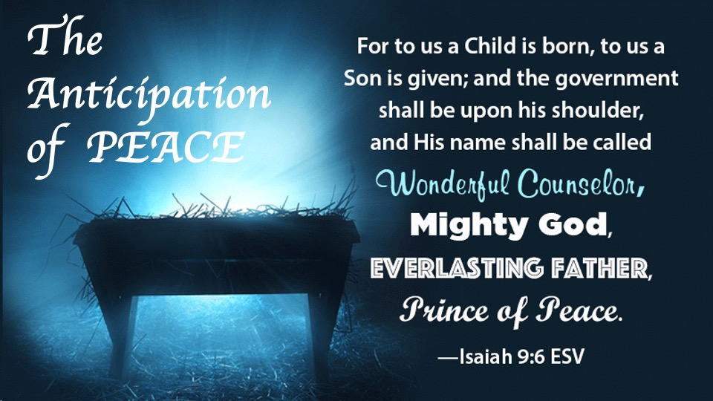
[The Peace Candle, also known as the “Bethlehem Candle”, is lit this week to assure us to remember that because of Jesus we can experience a life free from conflict and chaos. Peace given to a lost world – when Christ entered the world, He overcame the world.]

Advent Week 3, December 15-21

This week we focus on Joy, anticipation of Jesus’ first arrival as a babe and now the gift of salvation we have through Him.

Reflect on the fact that the Good News of Jesus Christ is here. The Savior is born, Christ the Lord.

They said to him, “In Bethlehem of Judea; for this is what has been written by the prophet: and you, Bethlehem, Land of Judah, are by no means least among the leaders of Judah; for from you will come forth a ruler who will shepherd my people Israel.’” (Matthew 2:5-6)

And my spirit has rejoiced in God my Savior. (Luke 1:27)

Joy is something that can empower us. Joy is knowing that our happiness comes from God alone. Joy is eager anticipation about wonderful things to come.

This week read Jeremiah 15:16, John 16:22, Romans 15:13, Galatians 5:22
- How can you share joy with others about the Savior having been born to save them?
- Do you have joy in the Lord and your relationship with Him?

[The Joy Candle, also known as the “Shepherd’s Candle”, is lit this week to remind us that our joy is not dependent on what is going on around us, the gift’s we receive or the people we are with. Our joy should come from knowing that Jesus came as a babe to Bethlehem, and now we anticipate His return for His Church.]

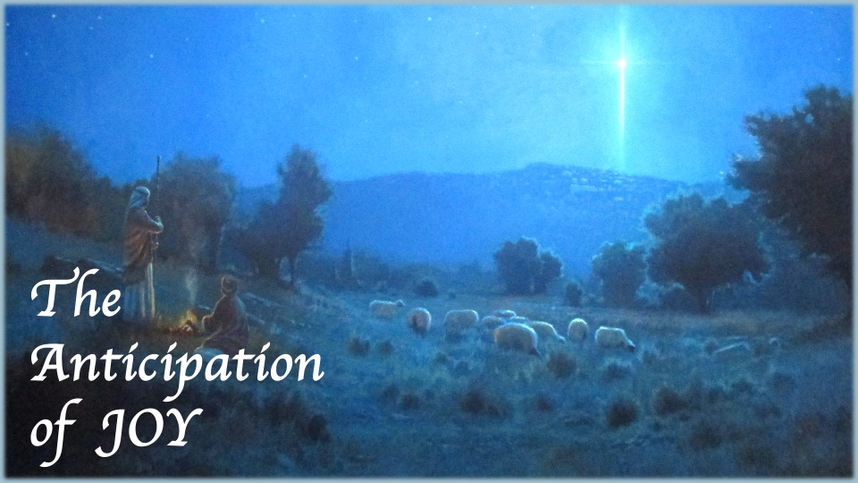

Advent Week 4, December 22-28

This week we focus on Love, Jesus’ entire purpose for being on earth.

Reflect on the fact that love is the greatest of all virtues. We cannot walk with Christ unless we have love, and we cannot have the Christmas Story without love.

“Know therefore that the Lord your God, He is God, the faithful God, who keeps His covenant and His lovingkindness to a thousandth generation with those who love Him and keep His commandments,” (Deuteronomy 7:9)

For God so loved the world, that He gave His only Son, that whoever believes in Him shall not perish, but have eternal life.” (John 3:16)

God loved us and sent His Son, Joseph loved Mary and he trusted God to save His family, Christ loves us and gave His life for ours.

This week read Matthew 8:17; 12:17-21, 1 Corinthians 13:4-7, 1 John 4:7-21
- Do you have the love of Jesus in your heart?
- What is God’s promise to us?

[The Love Candle, also known as the “Angel’s Candle”, is lit this week to assure us that as the angels proclaimed from the skies above that Jesus had been born, we can still hear the echo of their voices in our hearts today that a Savior is waiting to show us His love.]
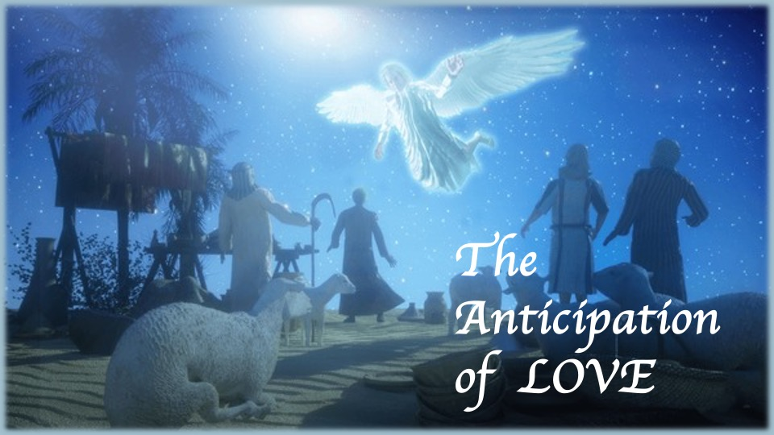

[The Christ Candle will be lit on Christmas Eve and represents the life of Christ. The color white is for purity – because Christ is our sinless, pure Savior.]

Christmas Day Reflection, December 25

Spend this morning preparing your heart, your mind, your spirit, and your family not just for Christmas celebrations but worshiping Jesus for everything He is: Savior, Lord, Judge, Shepherd, Redeemer, Holy One, Light, and Son of God.

The next day John saw Jesus coming toward him and said, “Here is the Lamb of God, who takes away the sin of the world!”
(John 1:29)

In the beginning was the Word, and the Word was with God,
and the Word was God. He was with God in the beginning. All things were created through Him, and apart from Him not one thing was created that has been created. Life was in Him, and that life was the light of men. That light shines in the darkness,
yet the darkness did not overcome it.
(John 1:1-5)

Shout triumphantly to the Lord, all the earth.
Serve the Lord with gladness; come before Him with joyful songs.
Acknowledge that Yahweh is God.
He made us, and we are His—
His people, the sheep of His pasture.
Enter His gates with thanksgiving and His courts with praise.
Give thanks to Him and praise His name.
For Yahweh is good, and His love is eternal;
His faithfulness endures through all generations.
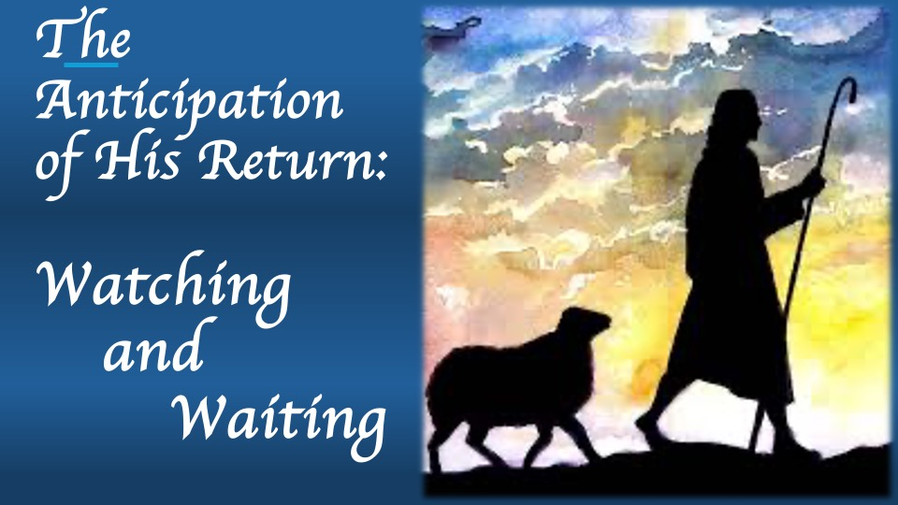
(Psalm 100)

Is Jesus your shepherd? Is He your Savior? Is He your Lord? How is He calling you to respond today?

