FBC Ministerial Staff

Mike Miller
Senior Pastor

Todd Vermilyea
Associate Pastor of Discipleship, Outreach & Missions

Steve Shepard
Associate Pastor of Worship & Music

Ryan Wicker
Associate Pastor of Education

Tim Hopper
Associate Pastor of Students

Ken Metcalf

Associate Pastor of Preschool & Children
Patty Goodwin
Director of Administration

First Baptist Church

“And He went up on the mountain and summoned those whom He Himself wanted, and they came to Him. And He appointed twelve, so that they would be with Him and that He could send them out to preach.”
- Mark 3:13-14 (NASB)

2501 Highway 70 East
Dickson, TN 37055
615.446.4640

Contact Pastor Mike

719.330.9978
mmiller@fbcdickson.org 400 West College, Dickson, TN

Our Website: fbcdickson.org
Facebook:
First Baptist Church, Dickson, TN
Twitter & Instagram @fbcdickson

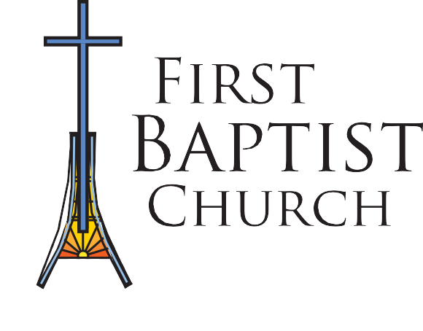Membership Guide

Following Jesus Loving Others Like Jesus
Telling The World About Jesus

New Member Process
Membership Orientation
Statement
Letter
Baptism

Request to join First Baptist Church
By Baptism, Letter, or Statement

Membership Orientation
Pastor Interview
A time when new member candidates join together for a brief overview of FBC, meet the leaders in the church, and learn about the Ministry Plan

Pastor Interview
Pastor or Associate Pastors will interview new member candidate to consult them on their course of direction in DiscipleLife classes and baptistm.
Baptism

DiscipleLife
Classes offered at FBC that equip new believers or growing believers to be disciples for Christ
Membership

Baptism
New member candidate will be baptized
if needed

Membership
Full membership begins after completing the New Member Process

